

**Placement Empowerment Program**

***Cloud Computing and DevOps Centre***

**Implement DNS for Your Application:** Set up a DNS record to map your web application’s IP or load balancer to a domain name.

**Name: Shahana.M.S Department : ADS**

**Introduction**

**Implementing DNS for your application ensures that users can access your web application using a human-readable domain name instead of an IP address. This setup improves user experience, scalability, and reliability by mapping your application’s public IP address or load balancer to a domain name using DNS records. AWS Route 53 and other DNS providers enable efficient domain name resolution with high availability and security.**

**Objective**

* **Configure a DNS record to map your web application’s IP address or load balancer to a domain name.**
* **Improve accessibility and ease of use for end users.**
* **Ensure high availability and seamless traffic routing.**
* **Integrate DNS with cloud services for scalability and security.**

**Overview**

**Setting up a DNS record involves creating an A record (for static IP addresses) or an ALIAS/CNAME record (for load balancers or cloud services). This ensures that users can access your application via a domain name rather than a numerical IP address. DNS services like Amazon Route 53 provide advanced features such as failover, latency-based routing, and DDoS protection.**

**Step by Step Overview**

Step 1: launch an instance with default settings

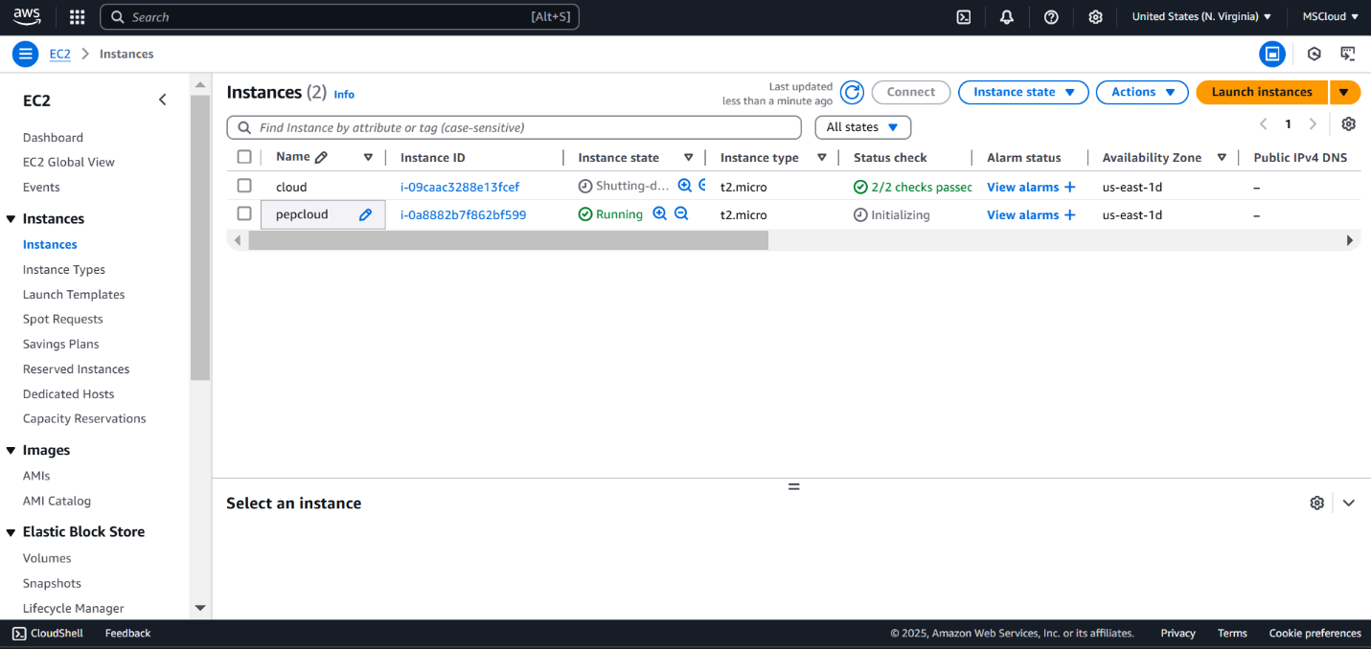

**Step 2: Open the EC2 dashboard**

Find your instance and copy the Public IPv4 Address.

By clicking the instance (you will have public ,private and all details of the instance in that copy just the Public Ip address)

### **3. Register a domain name**

You open route 53 and go to register domains on the left

* Click **Register Domain** and follow the steps to purchase a domain.

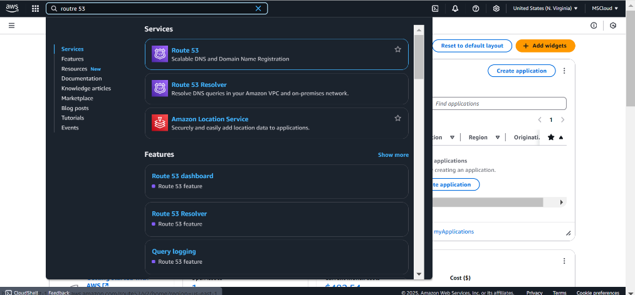

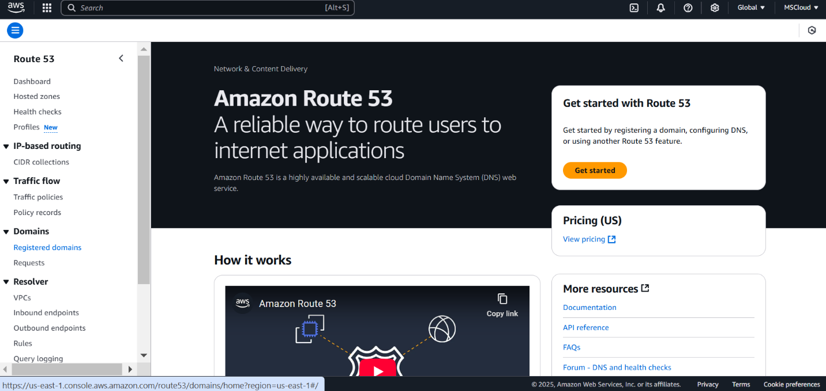

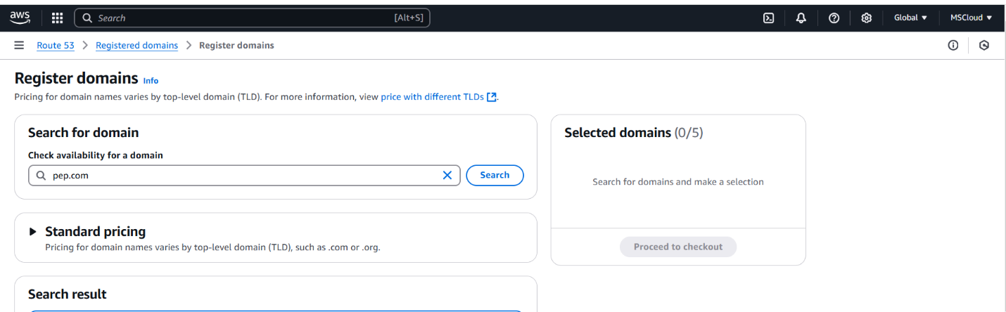

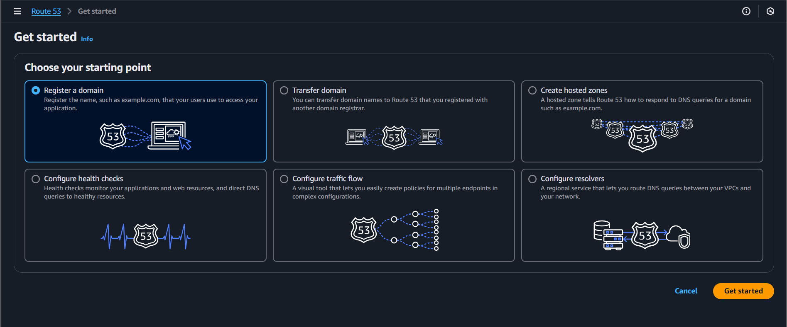

**4. Hosted Zone**

When you register the domain, AWS automatically creates a host zone.

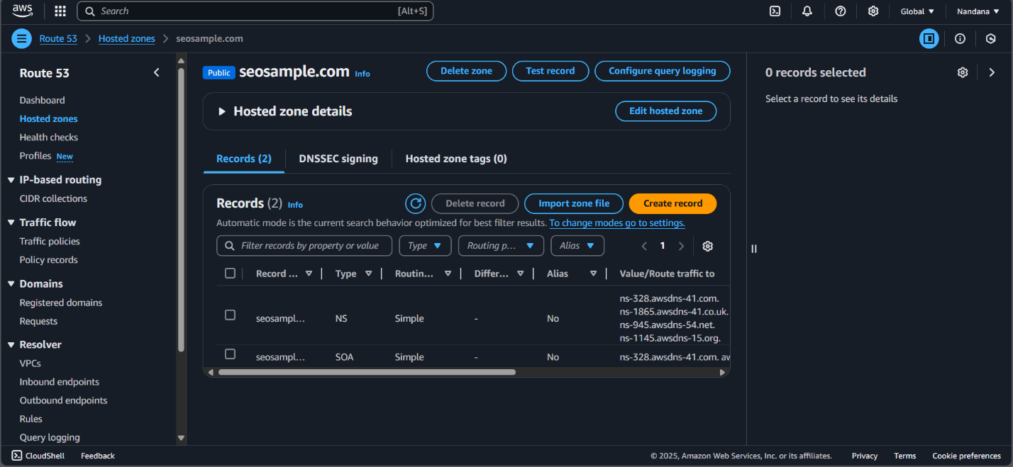

**5. Create Records**

Here you create records by setting TTl to 300 seconds,give name,typr(IPV4or IPv6)

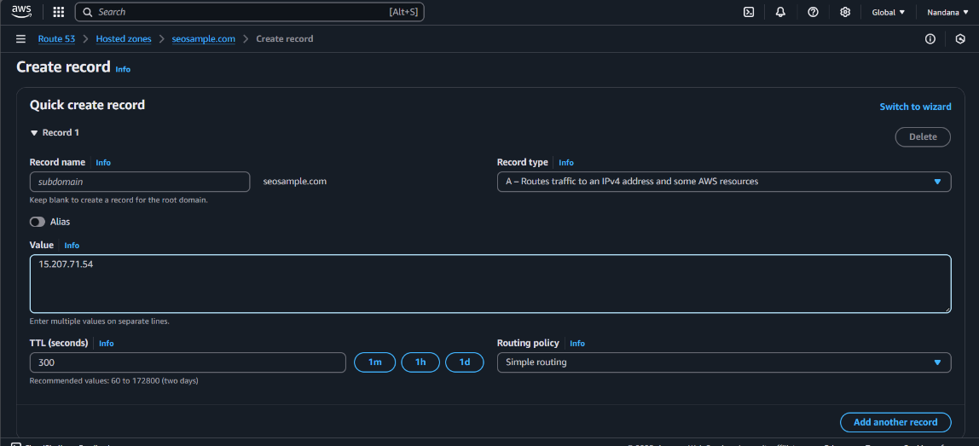

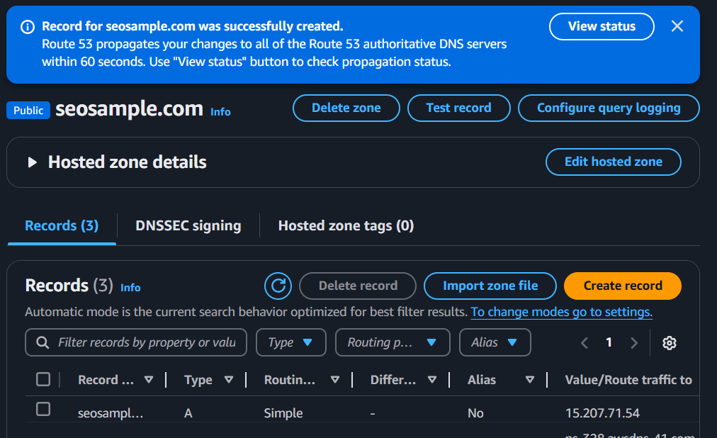

**6. Verify the Domain**

Wait a few minutes, then test if the domain resolves correctly.

Using **nslookup <domainname.com>** - you can test the configurations of your EC2 instance.

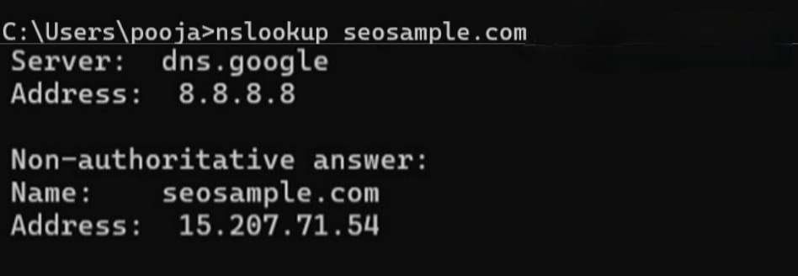

**Outcome**

* **A fully functional DNS setup linking your domain name to your application.**
* **Enhanced performance, security, and reliability through managed DNS services.**
* **Seamless traffic routing, load balancing, and failover capabilities.**
* **Improved user experience with a professional and accessible domain name.**